 | CHARLES MIX COUNTY
 |  | 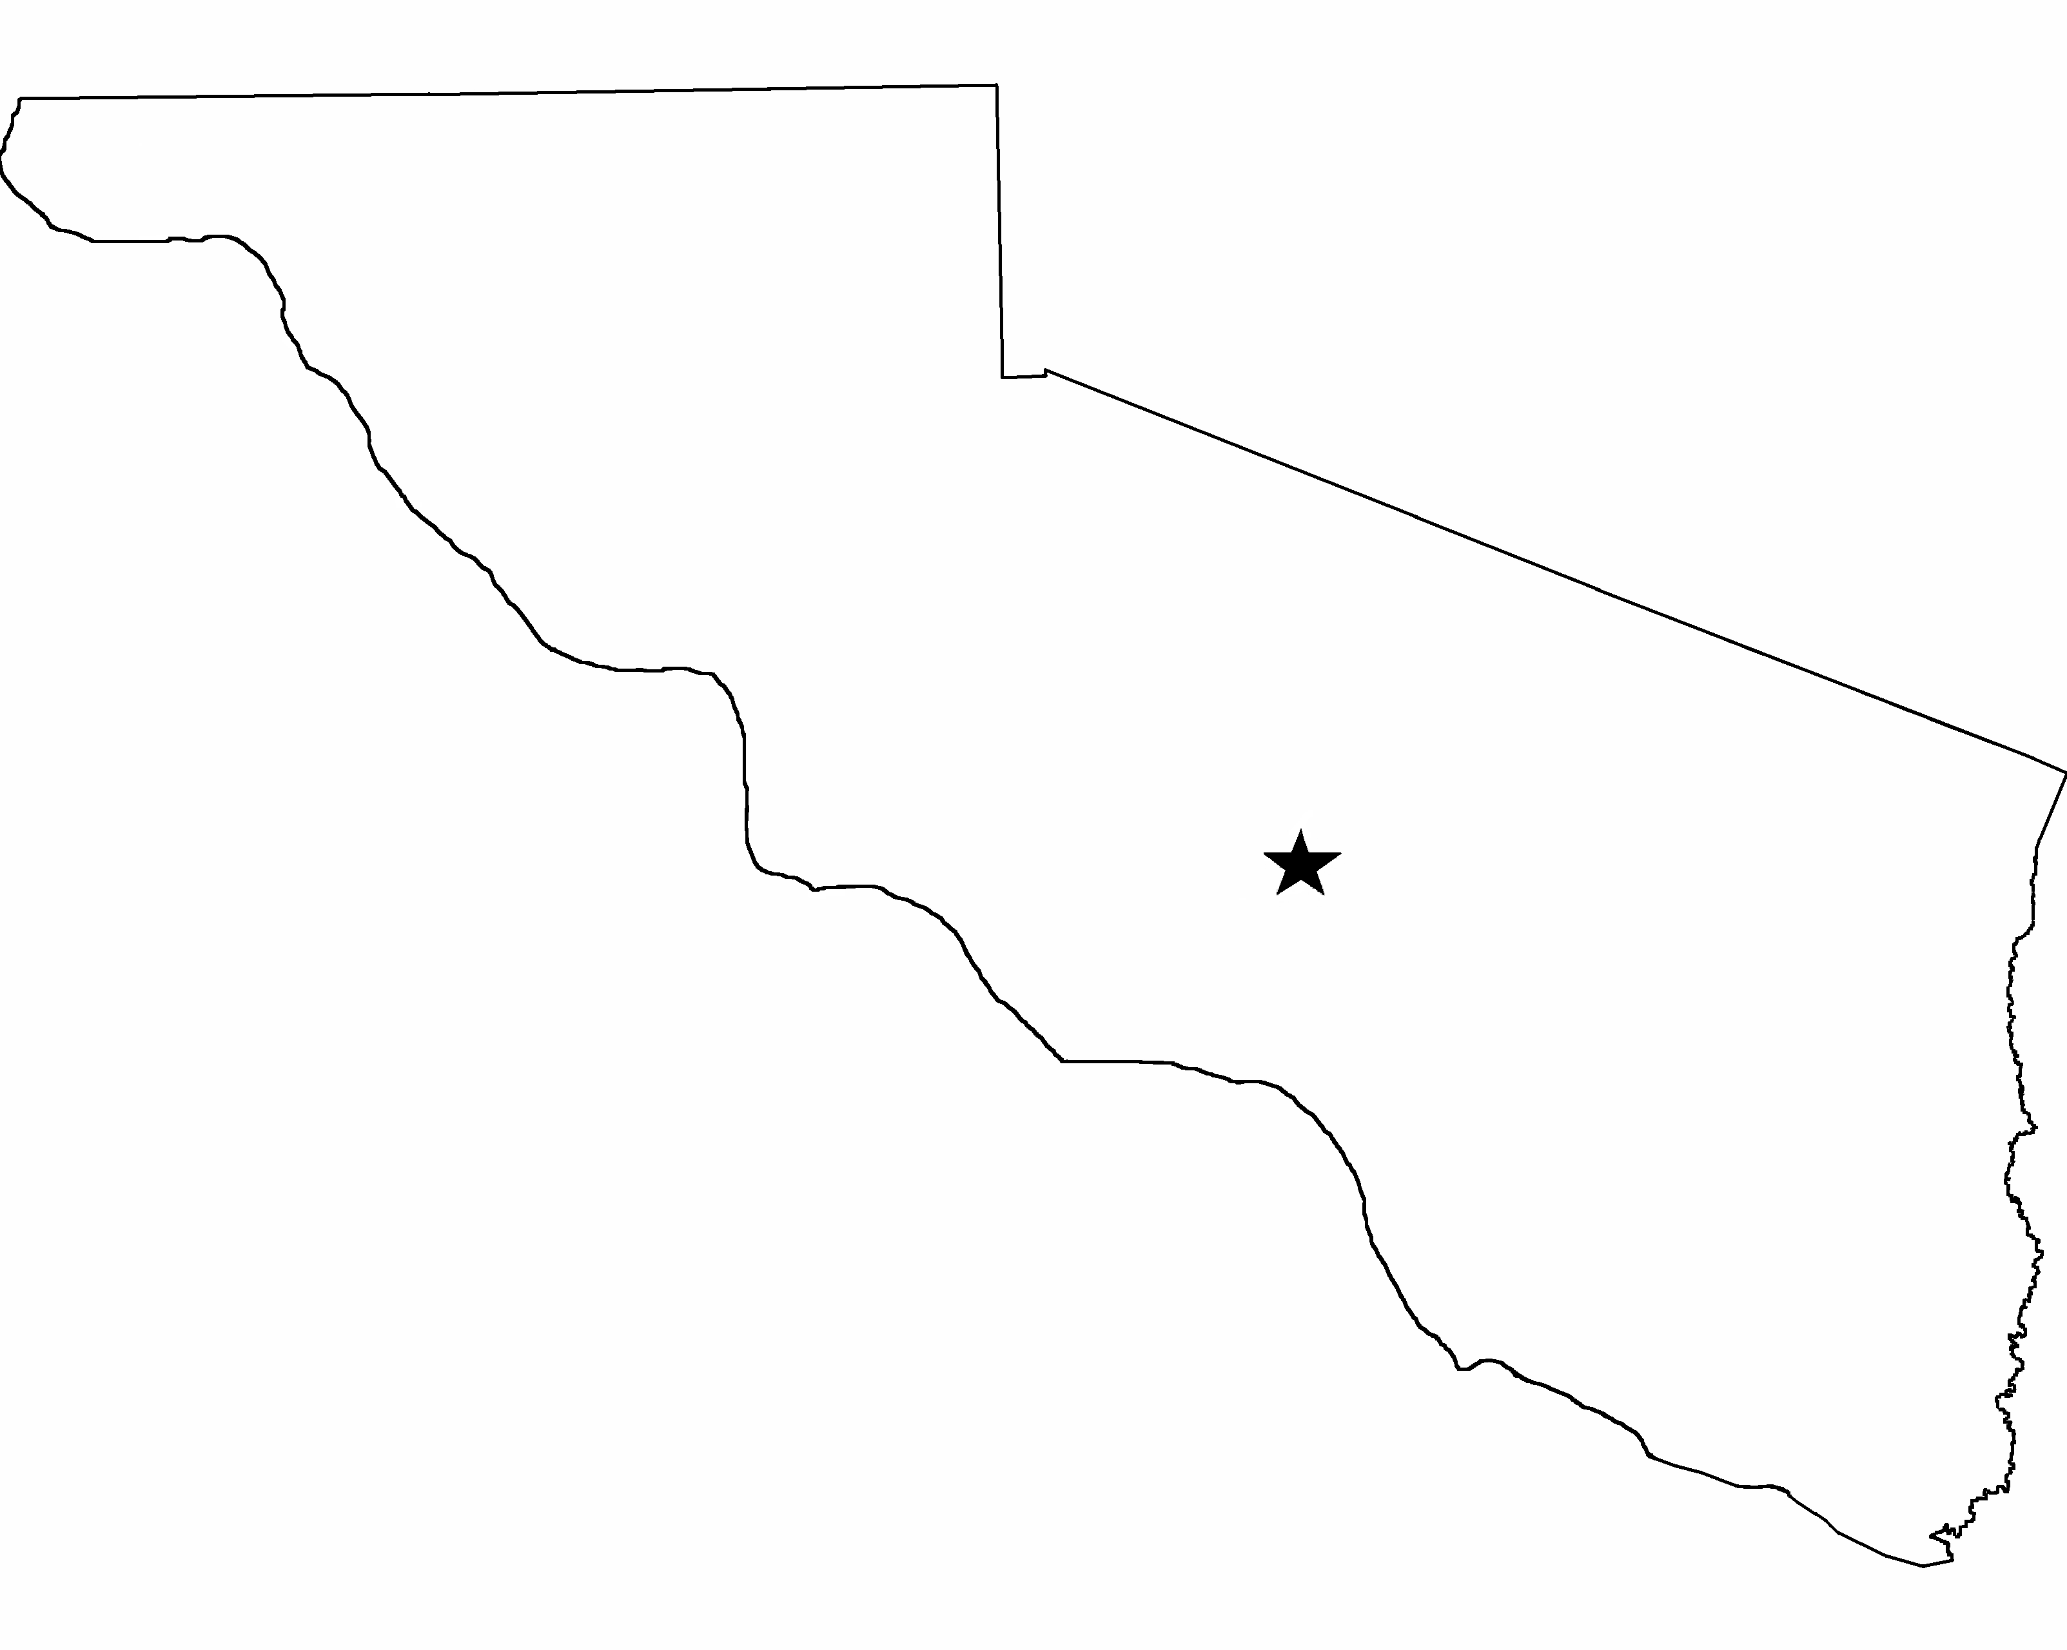 | Director of Equalization Office
 |  |  | PO Box 68
 |  |  | Lake Andes SD 57356-0068
 |  |  | (605) 487-7382 Office

BUILDING PERMIT PROCEDURES

- Fill out building permit application and proposed construction site plan if applicable.

- Return application and fee amount for building permit to the Director of Equalization Office as follows:

  - $5.00 for Centrally Assessed and Tax Exempt entities
  - $10.00 Any remodeling, additions, or other improvements to existing building sites
  - $10.00 Campground Improvements
  - $25.00 Establishment of a new building site

A removal permit is Free of Charge.

- Upon receipt of application and fee, the Director of Equalization Office will issue the building permit.

- Make checks payable to: Charles Mix County

Applications can be mailed to: Director of Equalization Office
Charles Mix County
PO Box 68
Lake Andes SD 57356-0068

Contact our office at: Phone: (605) 487-7382
Email: dweber@charlesmixcounty.org

